OPSC 7311 Assignment 2

2017

Adrian Beukes 15002426

**Content**

Introduction ………………………………………………………………………..2

Specifications ………………………………………………………………………..2

Flow Charts ………………………………………………………………………..3

UML Diagrams ………………………………………………………………………..4

Test Data ………………………………………………………………………..5

Help ………………………………………………………………………..8

Feedback ………………………………………………………………………..8

Conclusion ………………………………………………………………………..9

**Introduction:**

The purpose of this assignment is to develop a simple File Application, one that would be easy to use, understand, and doesn’t place too much stress on the hardware.

I decided to go with a simple Information collector app, it’s a basic notepad with set fields for specified values, but as well as a huge open field multiline value, where you can add as much information as you see fit. You may also use it only for one field, instead of filling out all the fields. As the fields are only there as a base guideline as to what would be the most common information that someone would want to save.

**Specifications:**

Functional Requirements:

The requirements for this project:

* Keep it simple
* Don’t strain the hardware
* Make use of a file
* Add to file
* Read file
* Show prompts that each are successful
* A basic help explanation

**Flow Charts:**

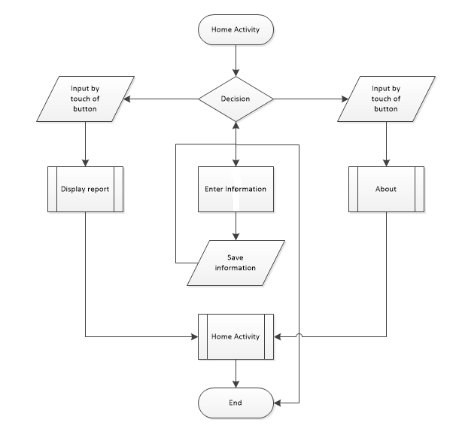

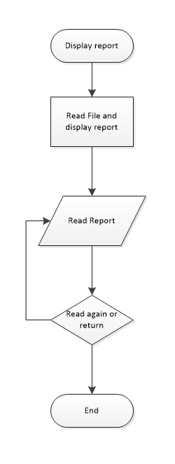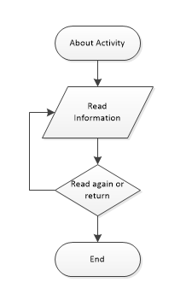

**UML Diagrams:**

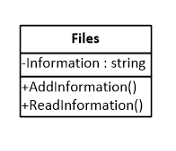

**Test Data**

A few screenshots of my program will follow, with explanation of what’s happening at each stage, as I progress in order to test it:

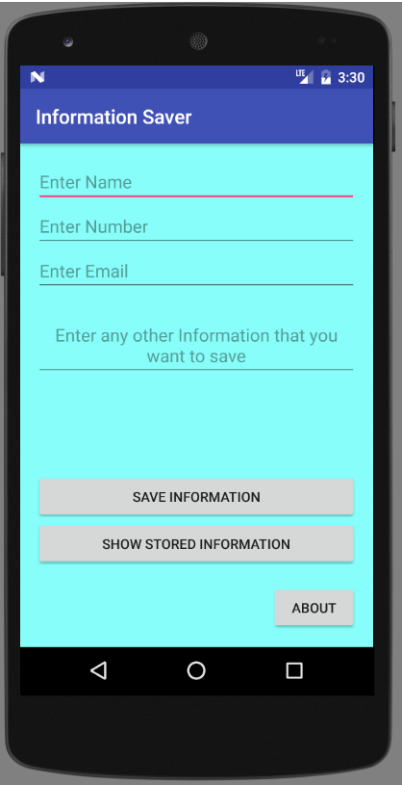

This is the main layout activity, here users are prompt to enter the specified information they would like to save, as well as an unspecified information field, which you can place any notes in. But a user is not forced to fill out each field, as they may only want to save one specified field in that instance.

After you’ve entered information, you need to save it, it and all previous information can then be viewed by pressing the show button.

You can also find a About button that will tell you a bit more about the application

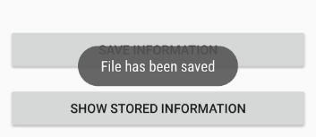

Prompt to display if you’re work has been successfully saved or not.

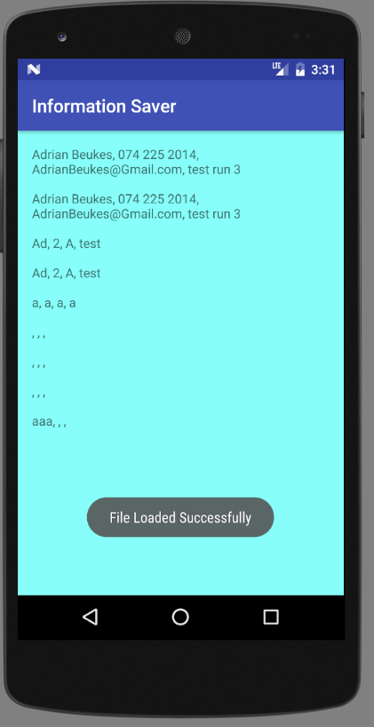

This is the report of all the files which has been saved, with all your information on each note.

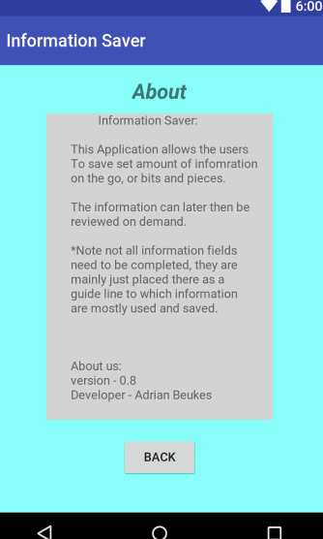

The above image is the about activity, which gives the user more information about the application and how to use it.

From this activity you can return to the main menu.

**Help:**

This is a guide that would take you step for step through the application.

On opening the application you will find yourself at the Home/Main Menu Activity.

Here you will find yourself with the option, to create a new note immediately without the stress of searching where to type

You also have a general information typing space for all other information.

After you’ve completed your note, it can then be saved to the text file with a simple button click.

It will prompt the user upon success.

Afterwards you can view all previously saved notes and scroll through them to the important one

**Feedback:**

|  |  |
| --- | --- |
| Comments | Reaction |
| Able to save blank information | Explained that’s part of the purpose, in case a user only wanted to save a set piece of information |
| Information not reflecting what is saved | Changed directory of where data is read |
| Why pass results | To show more of what can be achieved |
| Comments | Increased number of comments to explain code better |

**Conclusion:**

This project Had me doing research about file’s and what can be achieved with them, through the research I found out just how important part file’s play in each application we interact with daily and just how much can actually be saved on files.

I came to an understanding of where files can be saved and all the different ways it could be read and what type of information can be transferred by a simple text document.

I really enjoyed the challenge and it increased my thinking and research of what is needed.